**Bollinger Bands**

Bollinger Bands® are volatility bands placed above and below a moving average. Volatility is based on the [standard deviation](http://stockcharts.com/school/doku.php?id=chart_school:technical_indicators:standard_deviation_volatility), which changes as volatility increases and decreases. The bands automatically widen when volatility increases and narrow when volatility decreases.

## Calculation

* Middle Band = 20-day simple moving average (SMA)

* Upper Band = 20-day SMA + (20-day standard deviation of price x 2)

* Lower Band = 20-day SMA - (20-day standard deviation of price x 2)

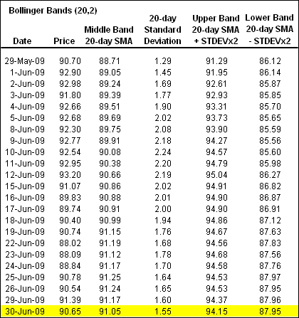

The middle band is a [simple moving average](http://stockcharts.com/school/doku.php?id=chart_school:technical_indicators:moving_averages) that is usually set at 20 periods. A simple moving average is used because the standard deviation formula also uses a simple moving average. The look-back period for the standard deviation is the same as for the simple moving average. The outer bands are usually set 2 standard deviations above and below the middle band.

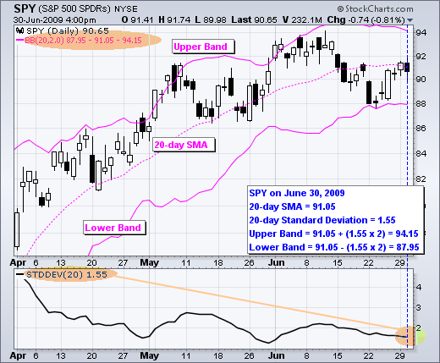

## **Signal: W-Bottoms**

A “W-Bottom” forms in a downtrend and involves two reaction lows

There are four steps to confirm a W-Bottom with Bollinger Bands.

* First, a reaction low forms. This low is usually, but not always, below the lower band.
* Second, there is a bounce towards the middle band.
* Third, there is a new price low in the security.
* This low holds **above** the lower band. The ability to hold above the lower band on the test shows less weakness on the last decline.
* Fourth, the pattern is confirmed with a strong move off the second low and a resistance break.

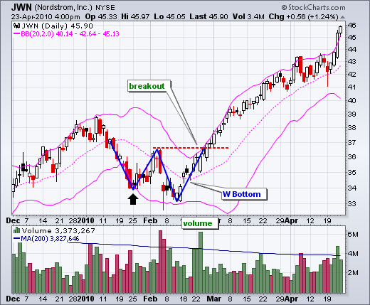

**Chart 3** shows Sandisk with a smaller W-Bottom in July-August 2009.

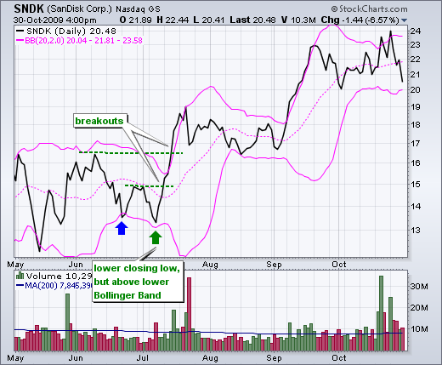

## **Signal: M-Tops**

Double tops, head-and-shoulders patterns, and diamonds represent evolving tops.

* First, a security creates a reaction high above the upper band.
* Second, there is a pullback towards the middle band.
* Third, prices move above the prior high but fail to reach the upper band.
* This is a warning sign. The inability of the second reaction high to reach the upper band shows waning momentum, which can foreshadow a trend reversal.
* Final confirmation comes with a support break or bearish indicator signal.

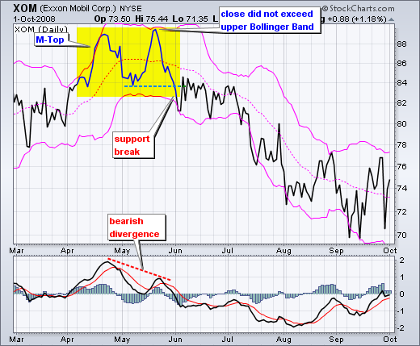

Chart 4 shows Exxon Mobil (XOM) with an M-Top in April-May 2008. The stock moved above the upper band in April.

There was a pullback in May and then another push above 90.

Even though the stock moved above the upper band on an intraday basis, it did not CLOSE above the upper band.

The M-Top was confirmed with a support break two weeks later. Also, notice that MACD formed a bearish divergence and moved below its signal line for confirmation

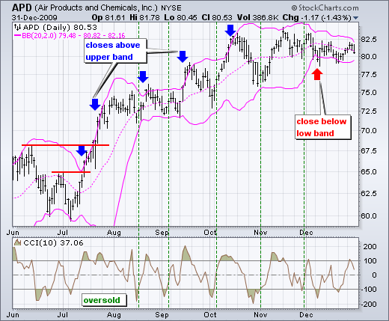

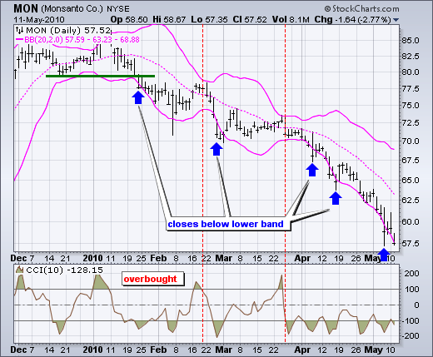

**Python Coding**

from datetime import datetime  
import backtrader as bt  
import numpy as np  
import pandas as pd  
import matplotlib.pyplot as plt  
  
data = pd.read_csv('C:\\Users\\Rama\\Desktop\\INR.csv')  
#x=data.iloc[:,5]  
#def movingaverage(values,window) :  
#     weights=np.repeat(1.0,window)/window  
#     smas=np.convolve(values,weights,'valid')  
#     return smas  
#SMA= movingaverage(x,50)  
n=50  
def BBANDS(data, window=n):  
 MA = data.Close.rolling(window=n).mean()  
 SD = data.Close.rolling(window=n).std()  
 data['UpperBB'] = MA + (2 * SD)   
 data['LowerBB'] = MA - (2 * SD)  
# data['MiddleBB'] = MA(data.Close,n)  
 return data  
BBANDS1 = BBANDS(data, n)  
print(BBANDS1)  
BBANDPLOT=pd.concat([BBANDS1.Close,BBANDS1.UpperBB,BBANDS1.LowerBB],axis=1).plot(figsize=(9,5),grid=True)  
print(data.UpperBB)